How can the use of 3D interactive applications improve education?

vipen mahay

1528344

2018

Contents

1 Introduction 2

2 Investigation 3

3 Prototype Application 5

3.1 Design 5

3.2 Implementation 6

3.3 Testing 9

3.3.1 Cross-Browser Testing 9

3.3.2 Functional Testing 9

4 Conclusion 11

5 References 12

# Introduction

As we are currently in the Information Age, the advancements in technology continue to exponentially improve. These advances in technology help improve sectors of industry such as health, financial, business and education. There have been significant strides in the health sector where they are able to provide emergency training (Bartoli, et al., 2012) and even surgical simulations (Molitch-Hou, 2017).

With more than 1.8 billion smartphone users in the world (Statista, 2015) and information being readily available on websites such as Google, the education sector is able to enhance their teaching via interactivity to closely simulate real-life situations at a fraction of the cost. It is also able to simulate situations which may not be realistically possible, for example, exploring the Solar System. By creating high-quality accurate models of planetary objects where real data can be gathered from organisations such as NASA, students can be educated in a more engaging way from the comfort of a classroom (or from home with the use of a smartphone).

This paper aims to address how technology, in the form of 3D interactive applications, can help improve education in particular by building a basic, yet accurate prototype of our Solar System. The application includes the Sun, the eight known planets and the Earth’s Moon each mapped with accurate high-quality textures and each with their own brief description.

# Investigation

3D interactive applications can be used in a vast array of environments. They are a way of visualising real-life objects, events, experiences etc. in a virtual world. They have started to gain some traction within many industries such as health, to treat patients (Stütz, et al., 2017), education, as training simulators (Bartoli, et al., 2012) (Molitch-Hou, 2017) and 3D visualisation (Silén, et al., 2008).

Interactive applications have been used to help patients through rehabilitation, as shown by a previous study (Stütz, et al., 2017), which helped patients with Frozen Shoulder partake in home physiotherapy to improve their wellbeing. The study developed a 3D smartphone app which helped real patients to correctly perform their physiotherapy, increasing their chances of recovery.

3D applications can also be used in education to teach students any number of subjects that may be too difficult, or too expensive, to conduct in reality. An example of this is medical emergency training where setting up a real-world scenario would be too cumbersome and too costly, instead can be created in a virtual environment (Bartoli, et al., 2012). In the study by Bartoli, et al., they designed a virtual first aid scenario where the participants would interact using gesture-based controls powered via a Kinect™. In this environment, the participant is allowed to free roam (move around and interact within a scene in no pre-determined sequence) so they are free to examine the patient immediately or first secure the area ensuring it is safe. By using a virtual scenario, it puts neither the patient nor the trainee at risk of injury if anything should go wrong.

Another study (Silén, et al., 2008) aimed at educating students within the health sector created complex 3D anatomical models using high-end CT scans and MRIs. This study was aimed at the possibility of promoting 3D visualisation for educational use to help enhance knowledge. The testing they conducted in this study was solely to gather data on whether 3D visualisation could be viable in an educational environment and whether it had any impact on the participants’ learning experiences. The results concluded that the participants were more likely to engage when seeing 3D interactive versions of the models and it more accurately represented the anatomy than seeing it in a textbook as they could see the relative sizes and locations of organs and such in comparison to each other.

Training simulators have also been developed to help train students and medical professionals learn surgical procedures using virtual reality (VR) headsets and specialised tools which closely mimic medical instruments used in the operating room (Molitch-Hou, 2017). In this virtual environment, the trainee uses a VR headset to immerse themselves in a virtual operating room where they must perform surgery on a patient. The operator uses ‘tools’ connected to the simulator which are similar to the real tools used in operations that provide force feedback to replicate the feel they would get for real so that the training is as close as possible to the real thing.

# Prototype Application

To introduce an example of the types of applications that can be used within an academic environment, a prototype version of a 3D interactive application depicting our Solar System was developed. This basic application shows each of the eight planets, the Earth’s Moon, and the Sun and a brief bio on each.

## Design

The 3D models were designed using 3ds Max 2018 and used in conjunction with three.js to enable the creation of a 3D interactive application accessible through a web browser. Each of the planetary objects is mapped with high definition and realistic textures to grant an immersive experience (Figure 1). The size of each object (with the exception of the Sun as three.js has certain limitations) are scaled accurately as well as the orbit sizes. Unfortunately, the orbit periods are not accurate, and each planet orbits the Sun once at the same rate as three.js was unable to handle the considerable number of keyframes needed to animate the objects appropriately.

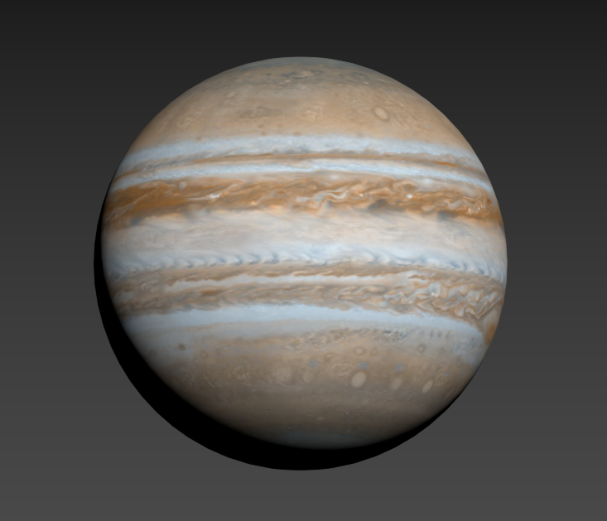

Figure 1. Model of Jupiter designed in 3DS Max 2018

## Implementation

As the Sun is a light source, the first type of lighting added to the scene was a hemisphere light which casts light from the sun on to the faces of all other planetary objects while casting shadows on the other side, for example, the face of the Earth that is facing the Sun would be lit while the half facing away would be dim, simulating night. Unfortunately, this causes lighting on the outer planets to be too dark to effectively view. As an alternate light source, an ambient light was created to light the entire scene with the intensity finely tuned to appropriately brighten all objects (Figure 2).

Orbit controls work perfectly for this type of application as it allows the user to rotate the camera around an object, effectively viewing it from any angle. This way, when the user wants to view Earth, for example, orbit controls lets them see all continents and both poles (Figure 2).

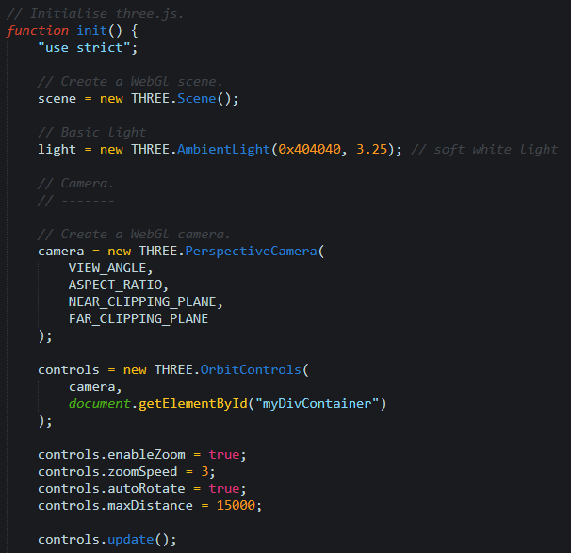

Figure 2. init function defining scene variables

The scene is viewed from a perspective camera and, initially, shows the entire scene. Along the side of the canvas is a navigation bar with the names of each planetary object which, when clicked, the camera attaches to the said object, and allows the user to zoom in and out and rotate around that single object. Each of the objects has their own function to change both the camera location and to update the description (Figure 3).

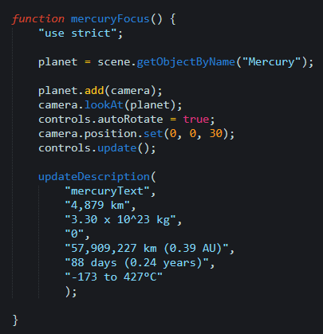

Figure 3. Function called when clicked on Mercury tab in app

When the object is clicked in the navigation bar, a brief description of the object’s size and temperature and such is also displayed (Figure 5). A function, updateDescription (Figure 4), provides a quick and easy way to populate the bio when clicked.

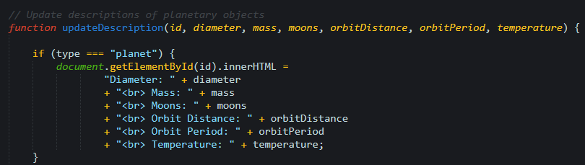

Figure 4. Function used to update each planetary object’s description

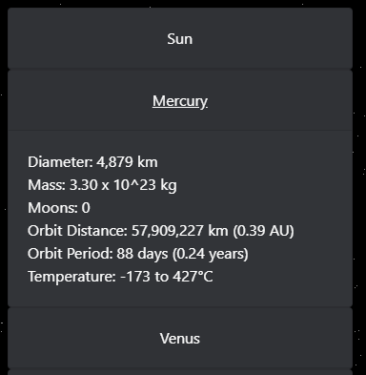

Figure 5.View of the planet’s description from within the application

The stars are created from within three.js using a snippet of code found in their documentation (three.js, n.d.). It effectively creates 50,000 stars in randomly generated locations to create a starfield background to the scene (Figure 6).

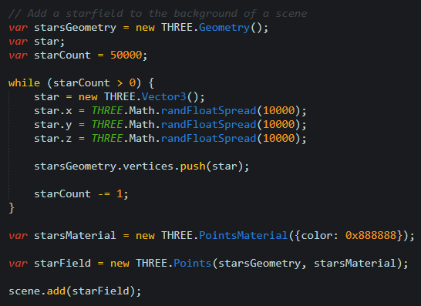

Figure 6. Creating a star field

## Testing

### Cross-Browser Testing

The Solar System 3D application was tested on some of the most popular web browsers in use today: Microsoft Edge 41; Google Chrome 66; Opera 53 and Mozilla Firefox 60. Testing on Safari was not possible as it is no longer supported on Windows machines. Each of the browsers worked perfectly with no issues, visual or functional. While the web application is designed specifically for PCs, it was also tested on a Chrome web browser on an Android phone. The entire scene loaded successfully with correct functionality and ran at 60fps, the only fault found was the navigation bar was not mobile responsive, fixable by adding a dropdown menu instead when viewing on a mobile device.

### Functional Testing

|  |  |  |  |  |  |
| --- | --- | --- | --- | --- | --- |
| Scenario | Steps | Input | Expected Result | Actual Result | Pass/  Fail |
| Check to see if entire scene is shown and loaded | Visit <http://mi-linux.wlv.ac.uk/~1528344/solar_system/index.html> | Left Mouse Click | Scene should load in roughly 5 seconds | Scene loaded in roughly 4 seconds | Pass |
| Check that Mercury focuses, and description is shown | Click Mercury tab | Left Mouse Click | Camera should focus on Mercury and description should be displayed on left | Mercury and description displayed | Pass |
| Check that Venus focuses, and description is shown | Click Venus tab | Left Mouse Click | Camera should focus on Venus and description should be displayed on left | Venus and description displayed | Pass |
| Check that Earth focuses, and description is shown | Click Earth tab | Left Mouse Click | Camera should focus on Earth and description should be displayed on left | Earth and description displayed | Pass |
| Check that Moon focuses, and description is shown | Click Moon tab | Left Mouse Click | Camera should focus on Moon and description should be displayed on left | Moon and description displayed | Pass |
| Check that Mars focuses, and description is shown | Click Mars tab | Left Mouse Click | Camera should focus on Mars and description should be displayed on left | Mars and description displayed | Pass |
| Check that Jupiter focuses, and description is shown | Click Jupiter tab | Left Mouse Click | Camera should focus on Jupiter and description should be displayed on left | Jupiter and description displayed | Pass |
| Check that Saturn focuses, and description is shown | Click Saturn tab | Left Mouse Click | Camera should focus on Saturn and description should be displayed on left | Saturn and description displayed | Pass |
| Check that Uranus focuses, and description is shown | Click Uranus tab | Left Mouse Click | Camera should focus on Uranus and description should be displayed on left | Uranus and description displayed | Pass |
| Check that Neptune focuses, and description is shown | Click Neptune tab | Left Mouse Click | Camera should focus on Neptune and description should be displayed on left | Neptune and description displayed | Pass |
| Check that entire scene is shown | Click Sun tab | Left Mouse Click | Camera should focus on entire scene and description of Sun should be displayed on left | Entire scene and description shown | Pass |
| Check camera rotation | Drag mouse around scene | Hold Left Mouse Click | Camera should rotate around object | Camera rotated around selected object | Pass |
| Check zoom | Scroll mouse wheel up/down | Middle Mouse Wheel | Scene should zoom in/out | Scene zoomed | Pass |

# Conclusion

With technology advancing as it is, it is imperative that it be utilised to its fullest potential by furthering education as it provides close simulations of real-world activities that cannot be replicated via textbook and makes for ideal learning as it can provide a cost-effective learning plan.

As detailed in Chapter 2, there are already many different ways 3D interactive applications can help enhance knowledge by creating interactive learning simulators, providing a safe environment to partake in otherwise potentially dangerous situations and visually show objects that would be difficult to easily access (such as parts of the anatomy).

Another major advantage of interactive applications is that they are extremely cost-effective, they essentially only need to be created once and can be distributed an unlimited amount of times. In the scenario of a physics class, for example, learning about particle accelerators would mean reading about them in textbooks or watching videos. While these are relatively cheap, they are less effective teaching tools than travelling to Geneva to visit the Large Hadron Collider (LHC). This, however, is a costly process, which can be avoided by building a virtual LHC.

# References

Bartoli, G. et al., 2012. *Emergency medicine training with gesture driven interactive 3D simulations.* New York, ACM.

Molitch-Hou, M., 2017. *3D Systems Medical Goes Virtual with VR OR Surgical Training.* [Online]   
Available at: https://www.engineering.com/3DPrinting/3DPrintingArticles/ArticleID/14190/3D-Systems-Medical-Goes-Virtual-with-VR-OR-Surgical-Training.aspx  
[Accessed 10 May 2018].

Silén, C. et al., 2008. Advanced 3D visualization in student-centred medical education. *Medical Teacher,* 30(5), pp. e115-e124.

Statista, 2015. *Number of smartphone users worldwide from 2014 to 2020 (in billions).* [Online]   
Available at: https://www.statista.com/statistics/330695/number-of-smartphone-users-worldwide/  
[Accessed 12 May 2018].

Stütz, T. et al., 2017. *An interactive 3D health app with multimodal information representation for frozen shoulder,* New York: ACM.

three.js, n.d. *PointsMaterial.* [Online]   
Available at: https://threejs.org/docs/#api/materials/PointsMaterial  
[Accessed 1 April 2018].